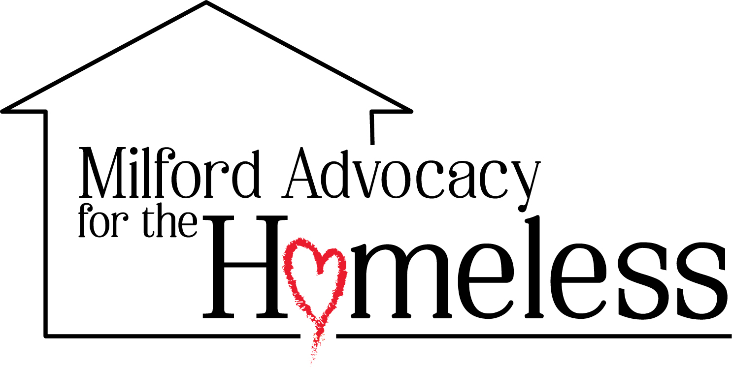
Wawa Food Recovery Driver

Reports to: Wawa Food Recovery Coordinator / Program Director - Bounty to Blessings
Status: Volunteer
Location: Milford, Delaware area
Time Commitment: 1 hour per day, 2:00 PM to 3:00 PM EST, one or more days per week or backup coverage

About MAH
Milford Advocacy for the Homeless (MAH) is a community-driven nonprofit based in Milford, Delaware, dedicated to supporting individuals and families experiencing homelessness, poverty, and crisis. Rooted in dignity, compassion, and service, we meet people where they are and walk alongside them as they rebuild their lives.
🌐 milfordadvocacyforthehomeless.org milfordadvocacyforthehomeless.org

Position Summary
The Wawa Food Recovery Driver supports MAH's Bounty to Blessings food recovery initiative by picking up recovered food from Wawa, counting the donated items, delivering the food to the assigned drop-off location, and sharing the count with the Wawa Food Recovery Coordinator.
This dependable volunteer role helps ensure surplus food is safely rescued and quickly connected to neighbors, partners, and programs that serve people facing food insecurity. Drivers may volunteer for one or more days each week or serve as a backup for vacations, emergencies, or schedule gaps.

Key Responsibilities

Food Recovery Pickup & Delivery
  - Arrive at Wawa during the scheduled pickup window, generally 2:00 PM to 3:00 PM EST
  - Pick up recovered food donations according to MAH and Wawa procedures
  - Count the recovered food items
  - Transport recovered food safely and directly to the assigned drop-off location
  - Drop off food with the designated MAH volunteer, partner, program site, or storage location
  - Provide the recovered food count to the Wawa Food Recovery Coordinator after each pickup
  - Notify the coordinator promptly if there are changes, delays, missed pickups, or concerns
  - Handle all donated food with care, gratitude, and respect

Food Safety & Accountability
  - Follow MAH food safety procedures for pickup, transport, and handoff
  - Keep recovered food clean, protected, and separated from personal items during transport
  - Deliver food promptly so it can be used safely and responsibly
  - Ask for guidance when food safety, packaging, timing, or storage questions come up
  - Maintain simple and accurate counts to support program tracking and reporting
  - Represent MAH with professionalism when interacting with Wawa staff and partners
Scheduling & Communication
- Volunteer for a consistent one-hour shift, one or more days per week, when possible
- Serve as a backup driver for vacations, illness, special needs, or open shifts when available
- Communicate availability clearly with the Wawa Food Recovery Coordinator
- Confirm coverage when assigned and give as much notice as possible if unavailable
- Use text, phone, or email to share counts and pickup updates
- Support a dependable process that Wawa staff, volunteers, and neighbors can trust
Team Support & Mission Focus
- Work cooperatively with the Wawa Food Recovery Coordinator and the Bounty to Blessings team
- Help identify simple ways to make pickups smoother and more consistent
- Treat every pickup as an opportunity to reduce waste and serve neighbors with dignity

Qualifications
Experience:
- Experience with food pickup, delivery, donation transport, or volunteer service helpful
- Experience communicating with store staff, volunteers, or community partners preferred
- No formal food recovery experience required, training and guidance will be provided
- Must have reliable transportation if using a personal vehicle
Skills:
- Reliable, punctual, and able to follow a simple pickup and drop-off process
- Able to volunteer from 2:00 PM to 3:00 PM EST for one or more assigned days
- Comfortable counting items and sending the count to the coordinator
- Able to lift, carry, and move food donations safely within personal ability
- Clear and respectful communication by phone, text, or email
- Able to work independently while keeping the coordinator informed
- Able to protect the dignity and privacy of neighbors served by MAH
Personal Attributes:
- Dependable, friendly, and service-minded
- Passionate about reducing food waste and helping neighbors facing food insecurity
- Respectful of Wawa staff, MAH volunteers, partners, and community members
- Flexible and willing to help as a regular driver or backup driver
- Committed to MAH's values of Passion, Service, Humanity, and Impact

Why Join MAH?
As a Wawa Food Recovery Driver, one dependable hour helps turn surplus food into nourishment, reduce waste, and serve neighbors with dignity.

