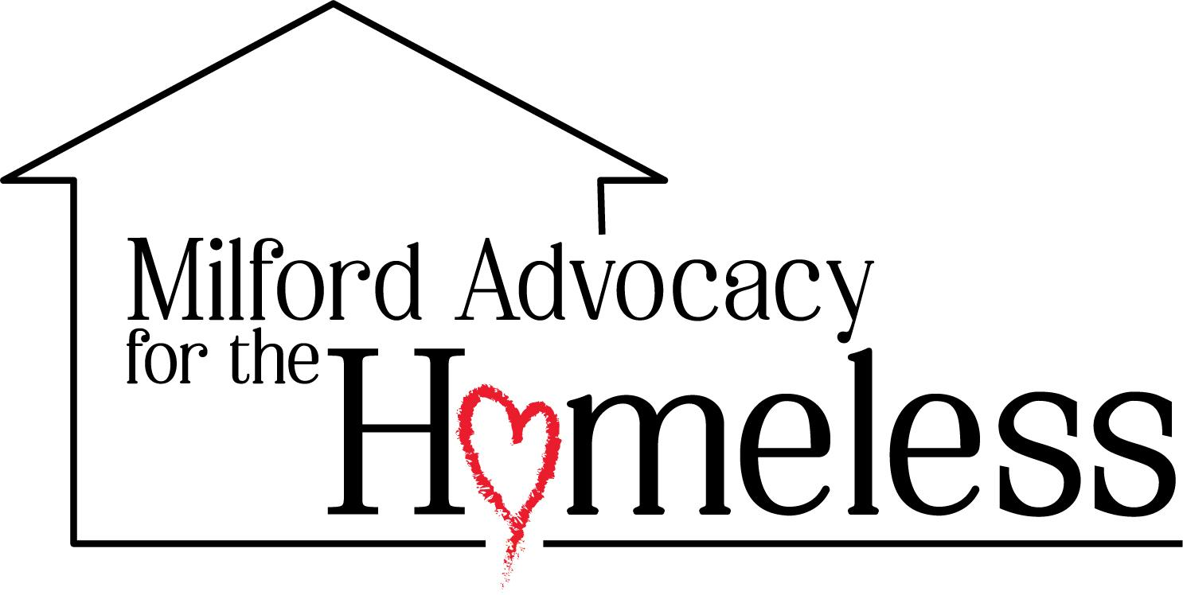 | Bounty to Blessings Driver
Reports to: Bounty to Blessings Program Director
Status: Volunteer
Location: Delaware
About MAH
Milford Advocacy for the Homeless (MAH) is a community-driven nonprofit based in Milford, Delaware, dedicated to supporting individuals and families experiencing homelessness, poverty, and crisis. Rooted in dignity, compassion, and service, we meet people where they are and walk alongside them as they rebuild their lives.
🌐 milfordadvocacyforthehomeless.org
Position Summary
The Bounty to Blessings Driver supports MAH’s food recovery and redistribution program by picking up recovered food from community donors and delivering Bounty Boxes and recovered food to vulnerable neighbors in our community. This volunteer role helps reduce food waste, strengthen food access, and ensure donated resources are moved safely and respectfully.
Drivers may serve through flexible hours, on-demand pick-ups, scheduled deliveries, or backup support during vacations, schedule gaps, and urgent needs. This role is ideal for someone who is dependable, compassionate, comfortable driving locally, and willing to serve neighbors with dignity and care.
Key Responsibilities
- Food Recovery Pick-Ups
- Pick up recovered food from restaurants, grocers, farms, community partners, and approved donation sites as assigned
- Follow scheduled and on-demand pick-up instructions, including time-sensitive food recovery needs
- Safely load and transport recovered food using a personal vehicle or an approved MAH vehicle when available
- Communicate pick-up status, delays, route changes, or concerns to the coordinator or program leadership
- Bounty Box Deliveries & Redistribution
- Deliver Bounty Boxes and recovered food to vulnerable neighbors, families, and approved community distribution points
- Treat every neighbor served with dignity, compassion, patience, and respect
- Protect confidentiality and privacy when interacting with neighbors and handling delivery information
- Help ensure food reaches the correct destination in a safe and timely manner
- Donation Counts & Communication
- Assist with the basic intake of recovered food when picking up donations
- Count or estimate recovered food items as requested and provide totals to the coordinator
- Support inventory tracking by reporting what was picked up, delivered, or returned
- Report damaged, spoiled, missing, or unusable items as soon as possible

- Vehicle Safety & Team Support
- Maintain a valid driver’s license, current auto insurance, and safe driving practices
- Keep the vehicle clean and suitable for transporting food donations
- Use safe lifting, loading, and unloading practices when moving food boxes
- Serve as a flexible backup driver for urgent needs, scheduled deliveries, or gaps in coverage
Qualifications
- Experience:
- Valid driver’s license, dependable transportation, and safe driving habits required
- Experience with delivery, food recovery, nonprofit service, or community outreach is helpful but not required
- Basic understanding of food safety is preferred, and training will be provided
- Skills:
- Reliable, responsive, and able to follow pick-up and delivery instructions
- Comfortable using phone, text, and navigation apps for routes and updates
- Able to lift, carry, load, and unload food boxes safely
- Able to manage flexible hours, on-demand pick-ups, and scheduled deliveries
- Personal Attributes:
- Passionate about serving vulnerable neighbors and reducing food waste
- Compassionate, respectful, dependable, and mission-centered
- Committed to protecting dignity, privacy, and trust in every interaction
Why Join MAH?
At MAH, every role contributes to creating real change in our community. As a Bounty to Blessings Driver, you help turn recovered food into practical support for neighbors facing hardship. Your time behind the wheel becomes part of a larger mission to reduce waste, restore hope, and make sure food reaches people who need it most.

